FinalReport:GrainPalette-ADeep LearningOdysseyinRiceType Classiﬁcation

# INTRODUCTION

## ProjectOverview

GrainPaletteisadeeplearning-basedwebapplicationdesignedtoclassifyﬁvedifferent varietiesofriceusingtransferlearningwithMobileNetV2.Thistoolaimstoassistfarmersin identifying rice types accurately without requiring expensive agricultural expert consultations.

## Purpose

Theprimaryobjectiveofthisprojectistoprovideanaffordableandeﬃcientsolutionforrice classiﬁcation.Byleveragingmachinelearning,farmerscanmakeinformeddecisionsaboutrice quality and market value.

# IDEATIONPHASE

## ProblemStatement

Riceclassiﬁcationistraditionallyperformedbyagriculturalexperts,makingitcostlyand inaccessibletomanyfarmers.Anautomatedsystemcanbridgethisgapbyofferinganinstant and reliable classiﬁcation tool.

## EmpathyMapCanvas

Understandingtheneeds,challenges,andperspectivesoffarmerstodevelopauser-friendly solution.

## Brainstorming

Identifyingpotentialmachinelearningmodels,datasetsources,andapplicationfeaturesto

maximizeusabilityandaccuracy.

# REQUIREMENTANALYSIS

## CustomerJourneyMap

Mappingouttheuserinteractionwiththewebapplication,fromimageuploadtoricevariety prediction.

## SolutionRequirement

* + - Image-basedclassiﬁcationofricevarieties.
    - WebinterfaceusingFlask.
    - Lightweightdeeplearningmodel(MobileNetV2)forfastpredictions.

## Data FlowDiagram

Illustratingtheprocessﬂowfromimageinputtoricevarietypredictionoutput.

## TechnologyStack

* + - **Frontend:**HTML,CSS,JavaScript
    - **Backend:**Flask(Python)
    - **Model:**MobileNetV2(TensorFlow/Keras)
    - **Database:**SQLite(ifapplicable)

# PROJECTDESIGN

## ProblemSolutionFit

Ensuringthemodelaccuratelyclassiﬁesricetypesandisaccessibletofarmersviaasimple web interface.

## ProposedSolution

ImplementingaFlask-basedwebappthatallowsuserstouploadricegrainimagesandreceive instant classiﬁcation results.

## SolutionArchitecture

High-levelarchitecturediagramdetailingmodeltraining,webhosting,anduserinteraction.

# PROJECTPLANNING&SCHEDULING

## ProjectPlanning

Timeline and milestones for dataset collection, model training, web development, and deployment.

# FUNCTIONALANDPERFORMANCETESTING

## PerformanceTesting

Evaluatingthemodel'saccuracy,speed,andeﬃciencyinclassifyingricevarieties.

# RESULTS

## OutputScreenshots

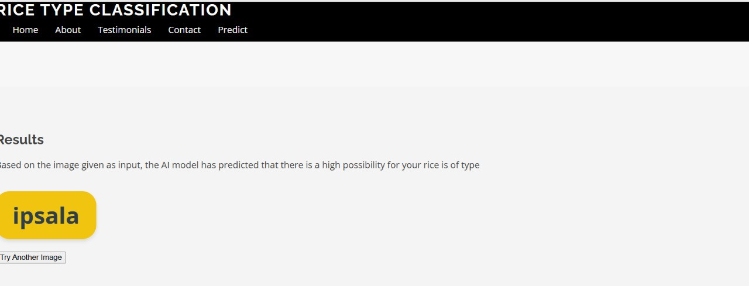

Displayingthewebappinterface,classiﬁcationresults,andmodelperformance.

# ADVANTAGES&DISADVANTAGES

* **Advantages:**Affordable,accessible,anduser-friendlyriceclassiﬁcation.
* **Disadvantages:** Accuracydependent ondataset quality,requires internetaccess.

# CONCLUSION

Summarizingprojectachievements,challenges,andpotentialimprovements.

# FUTURESCOPE

Enhancementssuchasintegratingmorericevarieties,improvingmodelaccuracy,and developing a mobile app version.

# APPENDIX

* **GitHub repository link: https://github.com/Nagaraju2716/RICE-CLASSIFICATION**
* **DatasetLink:**[RiceImageDataset](https://www.kaggle.com/datasets/muratkokludataset/rice-image-dataset)